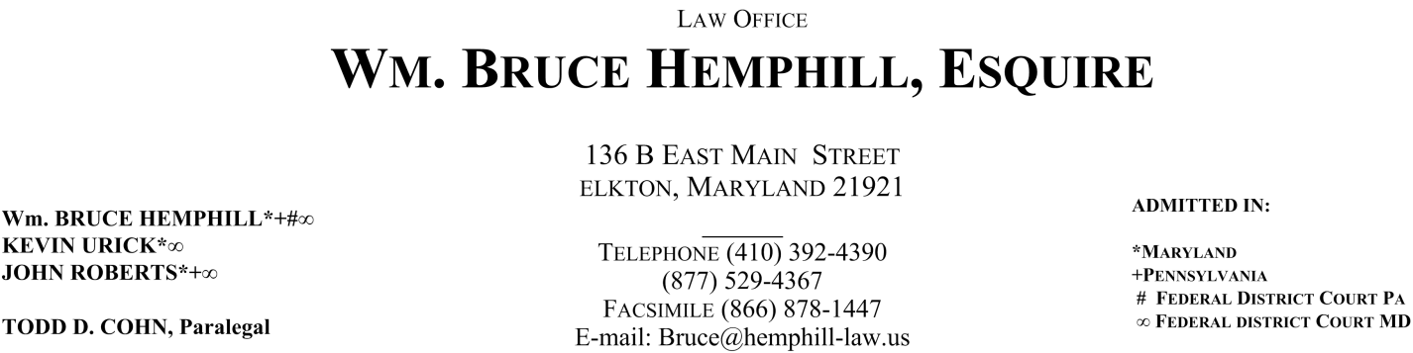

LIST OF DOCUMENTS & INFORMATION

Please provide as many of the following documents and information as possible (*If you do not have this information, we will acquire it on your behalf). They will aid in our preparation of your case:

- Copy of your automobile insurance policy.
- Copy of your health insurance policy.
- Contact Information for your insurance adjusters*.
- Copy of police report*.
- List of contact information for all of your treating physicians.
- Copies of any medical records in your possession*.
- Copies of any medical bills in your possession*.
- Photographs of your vehicle, injuries, accident scene*.
- List of contact information for all witnesses*.
- Contact information for your employer.
- List of all prior accidents of any kind.

The following documents and information will be needed in the event that we cannot settle the claim out of court. Please keep them in mind and begin gathering this information so that it will be available should we need it:

- Copies of income tax records for past five years
- List of all prior injuries or diseases (with-in 10 yrs.) of any kind.
- List of doctors who treated you for prior injuries (with-in 10 yrs.)
- List of all prior insurance claims of any kind.
- List of all prior court cases of any kind.

